

|  |  |
| --- | --- |
|  |  |

**FPT UNIVERSITY**

**DETAILED DESIGN DOCUMENT**

**<Project Code>**

|  |  |
| --- | --- |
| **<Group Code>** | |
| **Group Member** | <ID - Name> |
| <ID - Name> |
| <ID - Name> |
| <ID - Name> |
| **Supervisor** | <Name> |
| **Ext. Supervisor** |  |
| **Project Code** | <Code> |

- Hanoi, 05/2012 -

Table of Contents

1 DETAILED DESIGN.. 3

1.1 Common Design. 3

1.2 <UC xx- Use case name>. 3

1.2.1 Class Diagram.. 3

1.2.2 Class Description. 3

1.2.3 Screen Design. 4

1.2.4 Sequence Diagram.. 5

2 DATABASE DESIGN.. 5

2.1 Entity Relationship Diagram.. 5

2.2 Database Diagram.. 6

2.3 Table Descriptions 6

2.3.1 Table xxx. 6

2.3.2 Table xxx. 6

# **1** **DETAILED DESIGN**

## **1.1** **Common Design**

<Phần mô tả thiết kế cho các thành phần chung của tất cả các chức năng>

N/A?????

## **1.2** **<UC xx- Use case name>**

### **1.2.1** **Class Diagram**

<Sơ đồ quan hệ giữa các lớp của chức năng>

### **1.2.2** **Class Description**

<Phần mô tả chi tiết các lớp của chức năng>

#### **1.2.2.1** **<Class Name>**

|  |  |  |  |  |
| --- | --- | --- | --- | --- |
| Class | <Class Name> | | | |
| **Description** |  | | | |
| **Base Class** |  | | | |
| **Constructor** |  | | | |
| **Prototype** |  | | | |
| **Source File** |  | | | |
| **Namespace** |  | | | |
| **Attributes** | Name | Type | Description | |
|  |  |  | |
|  |  |  | |
|  |  |  | |
|  |  |  | |
| **Methods** | Name | Input | Output | Description |
|  |  |  |  |
|  |  |  |  |

#### **1.2.2.2** **<Class Name>**

|  |  |  |  |  |
| --- | --- | --- | --- | --- |
| Class | <Class Name> | | | |
| **Description** |  | | | |
| **Base Class** |  | | | |
| **Constructor** |  | | | |
| **Prototype** |  | | | |
| **Source File** |  | | | |
| **Namespace** |  | | | |
| **Attributes** | Name | Type | Description | |
|  |  |  | |
|  |  |  | |
|  |  |  | |
|  |  |  | |
| **Methods** | Name | Input | Output | Description |
|  |  |  |  |
|  |  |  |  |

......

### **1.2.3** **Screen Design**

<Screen Layout - Manage news- Delete news >

<Screen Definition>

**Table 4-x:** Manage news- Delete news

|  |  |  |  |  |  |  |
| --- | --- | --- | --- | --- | --- | --- |
| **No** | **Object/Control Name** | **Object/Control Name in English** | **Type** | **Required** | **Length** | **Description** |
| 1 |  |  |  |  |  |  |
| 2 |  |  |  |  |  |  |
| 3 |  |  |  |  |  |  |
| 4 |  |  |  |  |  |  |

### **1.2.4** **Sequence Diagram**

#### **1.2.4.1** **<Use-case ID - Use case name>**

...

#### **1.2.4.2** **<Use-case ID - Use case name>**

................

## 

## 

## 

## 

## 

## 

## 

## **1.4** **UC1-Connect Insurance**

### **1.4.1** **Class Diagram**

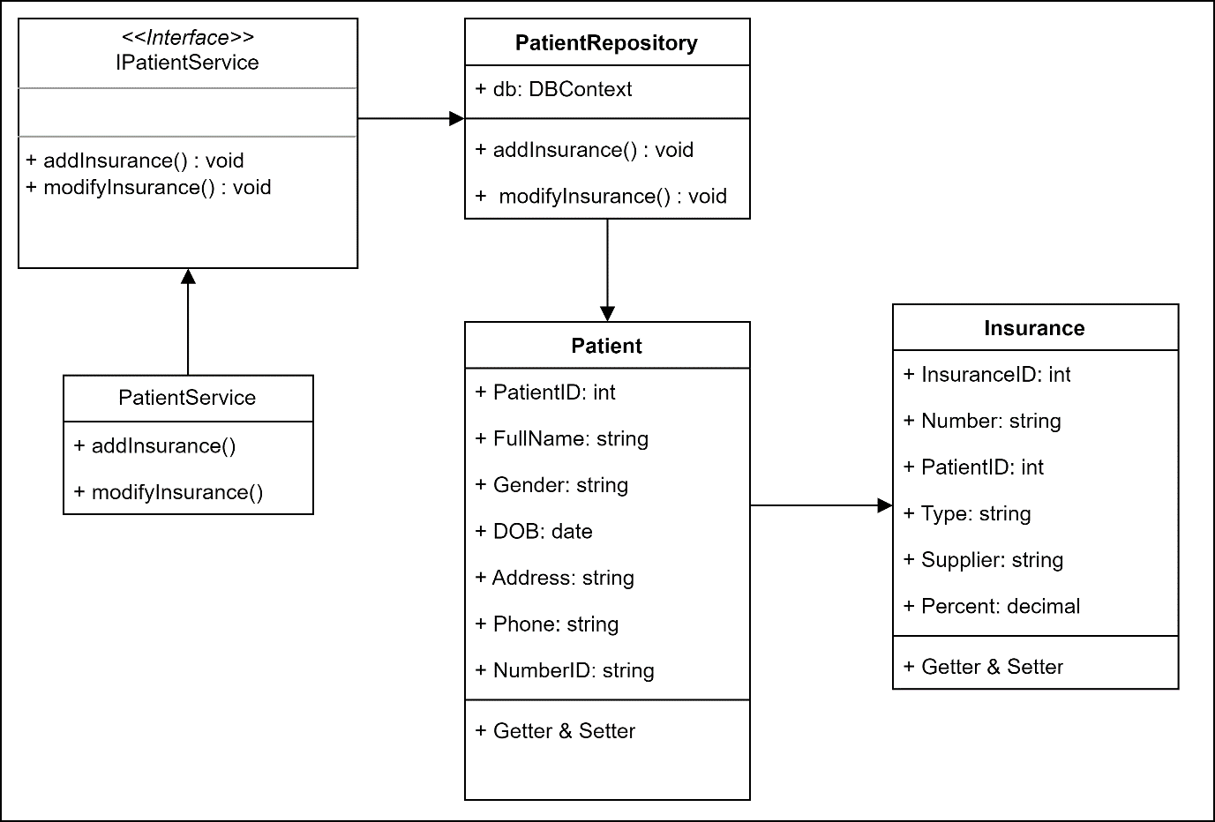

### **1.4.2** **Class Description**

#### **1.4.2.1** **Patient**

|  |  |  |  |  |
| --- | --- | --- | --- | --- |
| Class | Patient | | | |
| **Description** | Contains the patient’s information | | | |
| **Base Class** |  | | | |
| **Constructor** |  | | | |
| **Prototype** |  | | | |
| **Source File** |  | | | |
| **Namespace** |  | | | |
| **Attributes** | Name | Type | Description | |
| PatientID | string | Patient’s id in system | |
| FullName | string | Patient’s fullname | |
| Gender | string | Patient’s gender | |
| DOB | date | Patient’s date of birth | |
|  | Address | string | Patient’s Address | |
|  | PhoneNumber | string | Patient’s phone number | |
|  | NumberID | string | National identification number | |
| **Methods** | Name | Input | Output | Description |
| Getter & Setter |  |  | Get or set data |

#### **1.4.2.2** **Insurance**

|  |  |  |  |  |
| --- | --- | --- | --- | --- |
| Class | PatientInformation | | | |
| **Description** | This class contains the insurance which connected to patient’s profile | | | |
| **Base Class** |  | | | |
| **Constructor** |  | | | |
| **Prototype** |  | | | |
| **Source File** |  | | | |
| **Namespace** |  | | | |
| **Attributes** | Name | Type | Description | |
| InsuranceID | string | Insurance’s id in the system | |
| Number | string | Insurance identification number | |
| PatientID | string | Patient’s id in system | |
| Type | string | Insurance’s type | |
|  | Supplier | string | Supplier provide the Insurance | |
|  | Percent | Decimal | Insurance’s percent discount | |
| **Methods** | Name | Input | Output | Description |
| Getter & Setter |  |  | Get or set data |

#### 

#### **1.4.2.3** **PatientRepository**

#### 

|  |  |  |  |  |
| --- | --- | --- | --- | --- |
| Class | PatientInforRepository | | | |
| **Description** | This class is used to interact with the database and provides methods to perform read, write, update and delete operations on the data. The class provides an abstraction layer between different components of the system and the database and helps separate the business logic from the specific details of the database. | | | |
| **Base Class** |  | | | |
| **Constructor** |  | | | |
| **Prototype** |  | | | |
| **Source File** |  | | | |
| **Namespace** |  | | | |
| **Attributes** | Name | Type | Description | |
| context | DbContext | Interact directly with the database. | |
| **Methods** | Name | Input | Output | Description |
| addInsurance | Insurance |  | Add new Insurance to patient profile. |
|  | modifyInsurance | Insurance |  | Modify Insurance information |

#### 

#### **1.4.2.4** **PatientService**

|  |  |  |  |  |
| --- | --- | --- | --- | --- |
| Class | PatientInforRepository | | | |
| **Description** | PatientInforService | | | |
| **Base Class** |  | | | |
| **Constructor** |  | | | |
| **Prototype** |  | | | |
| **Source File** |  | | | |
| **Namespace** |  | | | |
| **Attributes** | Name | Type | Description | |
| patientRepository | PatientRepository |  | |
| **Methods** | Name | Input | Output | Description |
|  | addInsurance | Insurance |  | Add new Insurance to patient profile. |
|  | modifyInsurance | Insurance |  | Modify Insurance information |

### 

### 

### 

### 

### **1.4.3** **Screen Design**

Screen Layout - Add new Patient Information

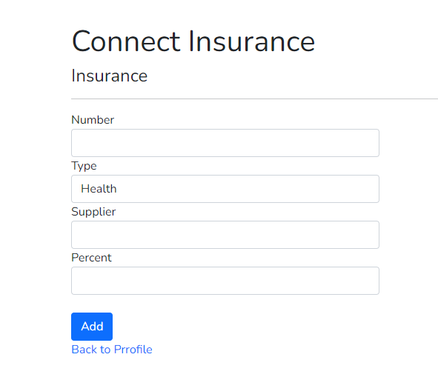

|  |  |  |  |  |  |
| --- | --- | --- | --- | --- | --- |
| **No** | **Object/Control Name** | **Type** | **Required** | **Length** | **Description** |
| 1 | Number | text | yes | 10 | Insurance identification number |
| 2 | Type | text | yes | 50 | Insurance’s type |
| 3 | Supplier | text | yes | 100 | Supplier provide the Insurance |
| 4 | Percent | text | yes |  | Insurance’s percent discount |

### **1.2.4** **Sequence Diagram**

#### **1.2.4.1** **<Use-case ID - Use case name>**

#### **1.2.4.2** **<Use-case ID - Use case name>**

#### 

# **2** **DATABASE DESIGN**

## **2.1** **Entity Relationship Diagram**

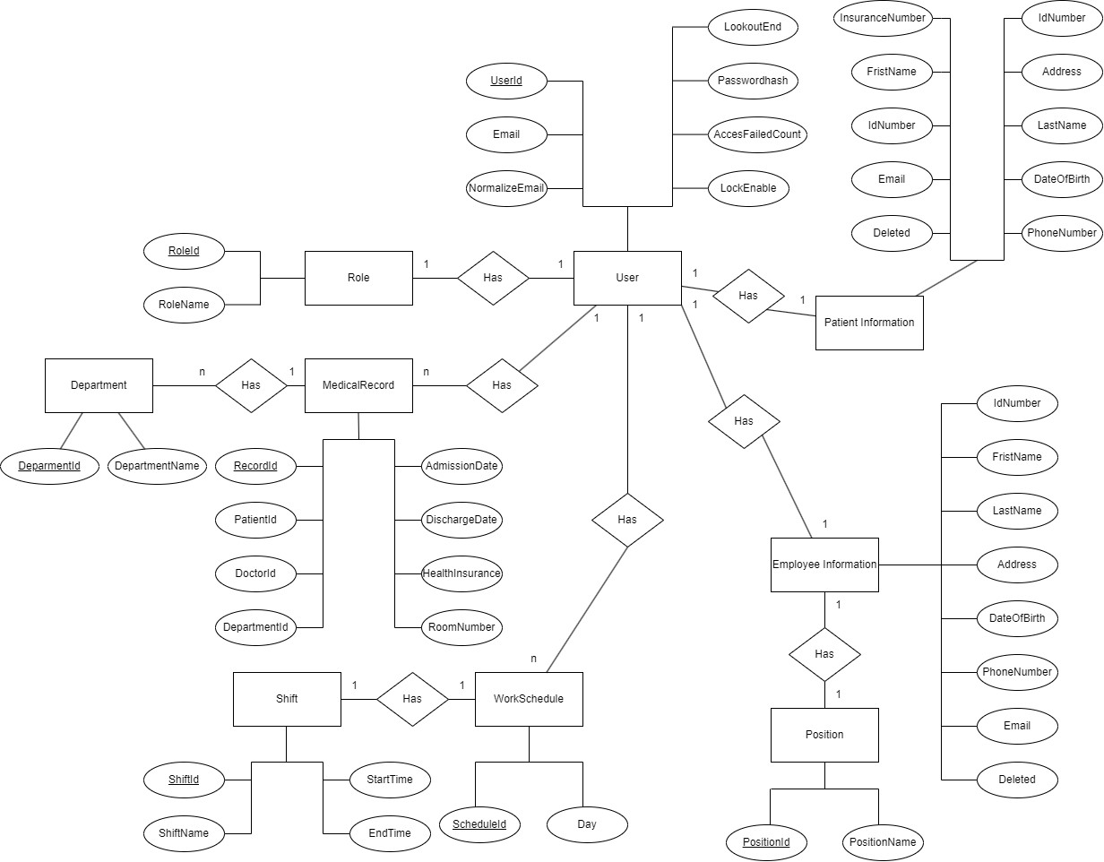

## **2.2** **Database Diagram**

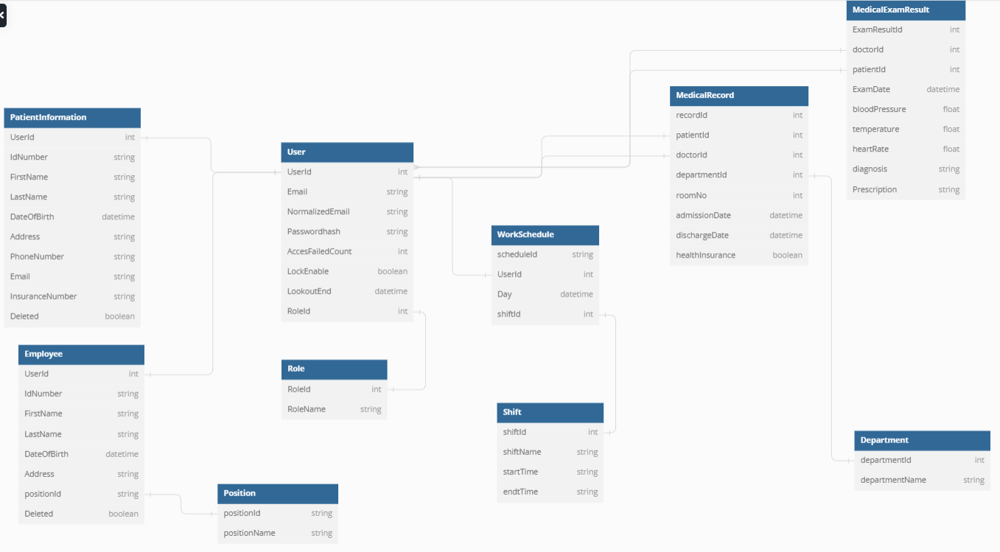

## **2.3** **Table Descriptions**

### **2.3.1** **User**

|  |  |  |  |  |
| --- | --- | --- | --- | --- |
| No. | Attribute | Type | Constraints | Description |
| 1 | UserId | int | not null |  |
| 2 | Email | string | not null, length<50 |  |
| 3 | NormalizedEmail | string | not null, length<50 |  |
| 4 | PasswordHash | string | not null, length<50 |  |
| 5 | AccessFailedCount | int | not null |  |
| 6 | LockEnable | boolean | not null |  |
| 7 | LockoutEnd | datetime | not null |  |
| 8 | RoleId | int | not null |  |

### **2.3.2** **Department**

|  |  |  |  |  |
| --- | --- | --- | --- | --- |
| No. | Attribute | Type | Constraints | Description |
| 1 | departmentId | int | not null |  |
| 2 | departmentName | string | not null, length<50 |  |

### **2.3.3** **MedicalRecord**

|  |  |  |  |  |
| --- | --- | --- | --- | --- |
| No. | Attribute | Type | Constraints | Description |
| 1 | recordId | int | not null |  |
| 2 | patientId | int | not null |  |
| 3 | doctorId | int | not null |  |
| 4 | departmentId | int | not null |  |
| 5 | roomNumber | int | not null |  |
| 6 | admissionDate | datetime | not null |  |
| 7 | dischargeDate | datetime |  |  |
| 8 | healthInsurance | boolean | not null |  |

### **2.3.4** **MedicalExamResult**

|  |  |  |  |  |
| --- | --- | --- | --- | --- |
| No. | Attribute | Type | Constraints | Description |
| 1 | ExamResultId | int | not null |  |
| 2 | patientId | int | not null |  |
| 3 | doctorId | int | not null |  |
| 4 | ExamDate | datetime | not null |  |
| 5 | bloodPressure | float | not null |  |
| 6 | temperature | float | not null |  |
| 7 | heartRate | float | not null |  |
| 8 | diagnosis | string | not null |  |
| 9 | Prescription | string | not null |  |

### **2.3.5** **Role**

|  |  |  |  |  |
| --- | --- | --- | --- | --- |
| No. | Attribute | Type | Constraints | Description |
| 1 | RollId | int | not null |  |
| 2 | RollName | string | not null, length<50 |  |

### **2.3.6** **Position**

|  |  |  |  |  |
| --- | --- | --- | --- | --- |
| No. | Attribute | Type | Constraints | Description |
| 1 | PositionId | int | not null |  |
| 2 | PositionName | string | not null, length<50 |  |

### **2.3.7** **EmployeeInformation**

|  |  |  |  |  |
| --- | --- | --- | --- | --- |
| No. | Attribute | Type | Constraints | Description |
| 1 | UserId | int | not null |  |
| 2 | IdNumber | string | not null, length<50 |  |
| 3 | FirstName | string | not null, length<50 |  |
| 4 | LastName | string | not null, length<50 |  |
| 5 | DateOfBirth | datetime | not null |  |
| 6 | Address | string | not null, length<100 |  |
| 7 | PhoneNumber | string | not null, length=10 |  |
| 8 | positionId | int | not null |  |
| 9 | Deleted | boolean | not null |  |

### **2.3.8** **PatientInformation**

|  |  |  |  |  |
| --- | --- | --- | --- | --- |
| No. | Attribute | Type | Constraints | Description |
| 1 | UserId | int | not null |  |
| 2 | IdNumber | string | not null, length<50 |  |
| 3 | FirstName | string | not null, length<50 |  |
| 4 | LastName | string | not null, length<50 |  |
| 5 | DateOfBirth | datetime | not null |  |
| 6 | Address | string | not null, length<100 |  |
| 7 | PhoneNumber | string | not null, length=10 |  |
| 8 | Email | string | not null, length<50 |  |
| 9 | InsuranceNumber | string | not null,  length<20 |  |
| 10 | Deleted | boolean | not null |  |

### **2.3.9** **WorkSchedule**

|  |  |  |  |  |
| --- | --- | --- | --- | --- |
| No. | Attribute | Type | Constraints | Description |
| 1 | ScheduleId | int | not null |  |
| 2 | UserId | int | not null |  |
| 3 | Day | datetime | datetime |  |
| 4 | shiftId | int | not null |  |